STAT 345 Midterm Project

Due March 29

**Introduction**

This project entails analyzing NBA data specifically focusing on the Milwaukee Bucks' performance during the years 2000, 2010, and 2021. The objective is to examine both made and missed shots by the team throughout these years, along with assessing individual players' shooting percentages in relation to their total number of shots made.

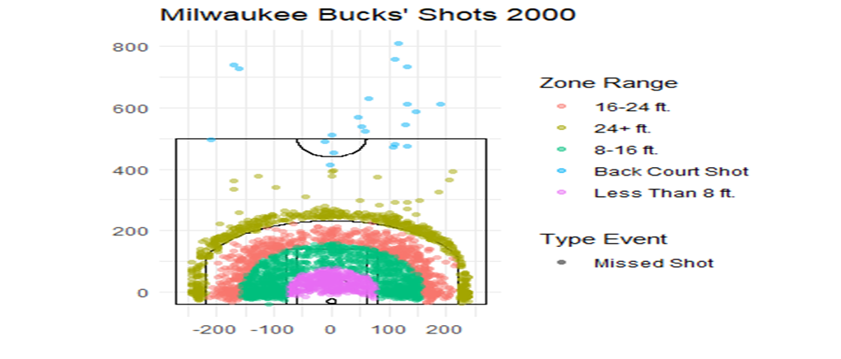

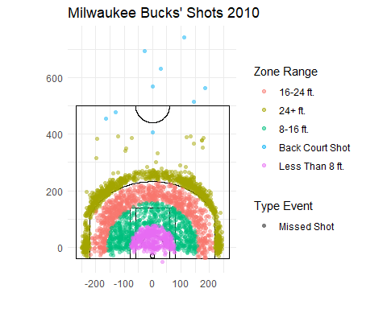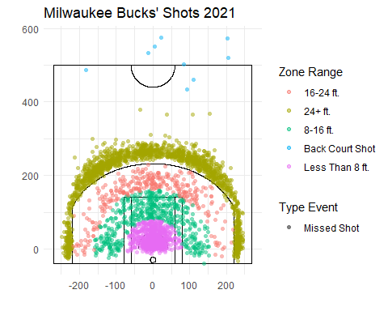

* This visualization illustrates missed shots, with colors representing the distance of players from the basket. A discernible trend emerges across the years, notably in 2000, 2010, and 2021. Over time, there appears to be a shift in shot selection, particularly evident inside the three-point line, which seems less favored compared to earlier periods. This shift is likely influenced by advancements in sports analytics, prompting changes in shooting preferences. For instance, in 2021, there’s a noticeable inclination towards shooting from farther distances, possibly driven by the desire for higher point returns. However, this emphasis on longer-range shots also introduces challenges in accuracy, contributing to increased instances of missed shots. In contrast, players in 2000 and 2010 may have prioritized scoring efficiency over maximizing point potential, as reflected in their shot distribution. Analyzing missed backcourt shots within this datasets provides valuable insights into shot selection, scoring opportunities, defensive pressure, and player performance, enhancing understanding of the game’s dynamics and identifying areas for improvement

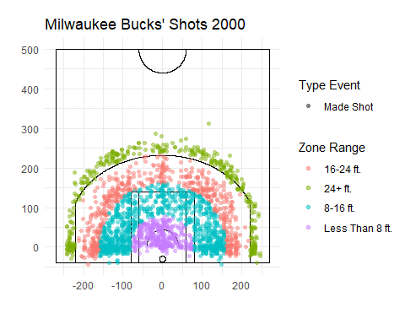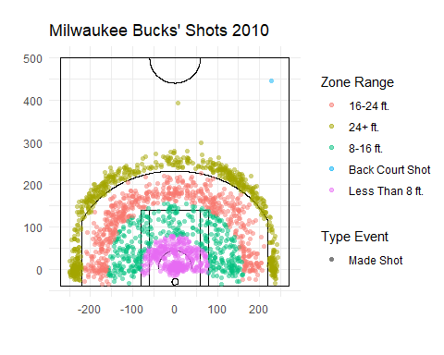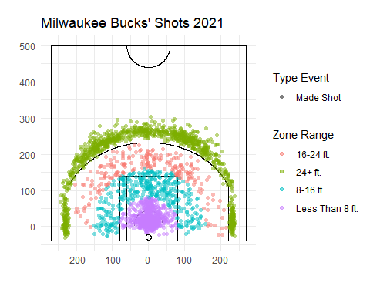

* The graph depicting shots reflects a consistent trend over the years, indicating a shift in players’ scoring strategies. As time progresses, players increasingly opt for shots from the 24+ft zone to accumulate points more rapidly, as observed prominently in 2021. This trend is accompanied by a significant number of shots attempted near the basket, potentially allowing for rebound opportunities if long-distance attempts fall short, aligning with basketball rules. In contrast, in 2000 and 2010, players predominantly focused on scoring within the 16-24ft range, overlooking the potential for higher point gains from shots beyond 24ft, a nuance highlighted by the 2021 data. Additionally, the inclusion of backcourt shots as made shots in 2010 underscores the remarkable skill required to successfully score from such distances, particularly under pressure, contributing significantly to a team’s overall score and often regarded as a noteworthy achievement in basketball.

Home FG%: 0.4666014

Away FG%: 0.4578726

Further analysis was conducted to examine the distribution of home and away games, revealing that approximately 46.66% of the games were played at home, while 45.79% were played away, spanning the years 2000, 2010, and 2021 respectively.

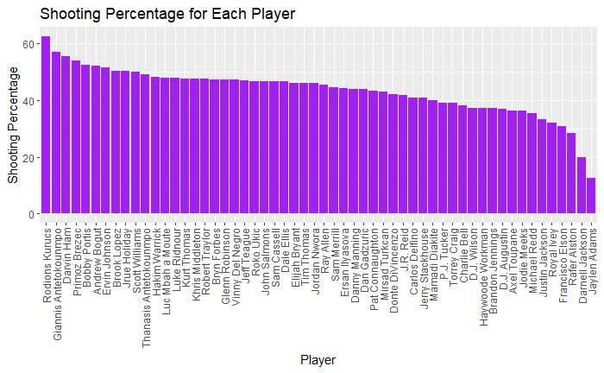- The graph illustrates the shooting percentages of players over the selected years, arranged from highest to lowest. For instance, Rodions Kurucs, standing at 6 ft 9, consistently exhibits high shooting percentages during this period. On the other hand, Jaylen Adams, a 6 ft point guard, demonstrates comparatively lower shooting percentages.

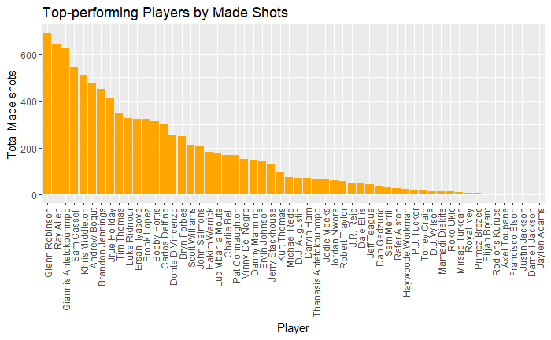

* On the contrary, this graph reveals that high shooting percentages do not necessarily correlate with high accuracy. For example, while Kurucs records the highest number of shots attempted, he ranks third in terms of shots made, indicating a lower accuracy rate than expected. Conversely, Glenn tops the list for the highest number of made shots across the selected years, yet his shooting percentage ranks 19th, suggesting greater accuracy than Kurucs. Additionally, Adams, despite having shooting percentages, fails to convert any shots, likely due to his role as a point guard on the court.